Class (mutable)

Google python: class name start with lowercase letter (words connect with ‘_’)

e.g. sort_string()

python: class name start with capital letter

e.g. Student()

* Similar to string, tuple, list, dictionary (string, tuple are immutable & list, dictionary are mutable)

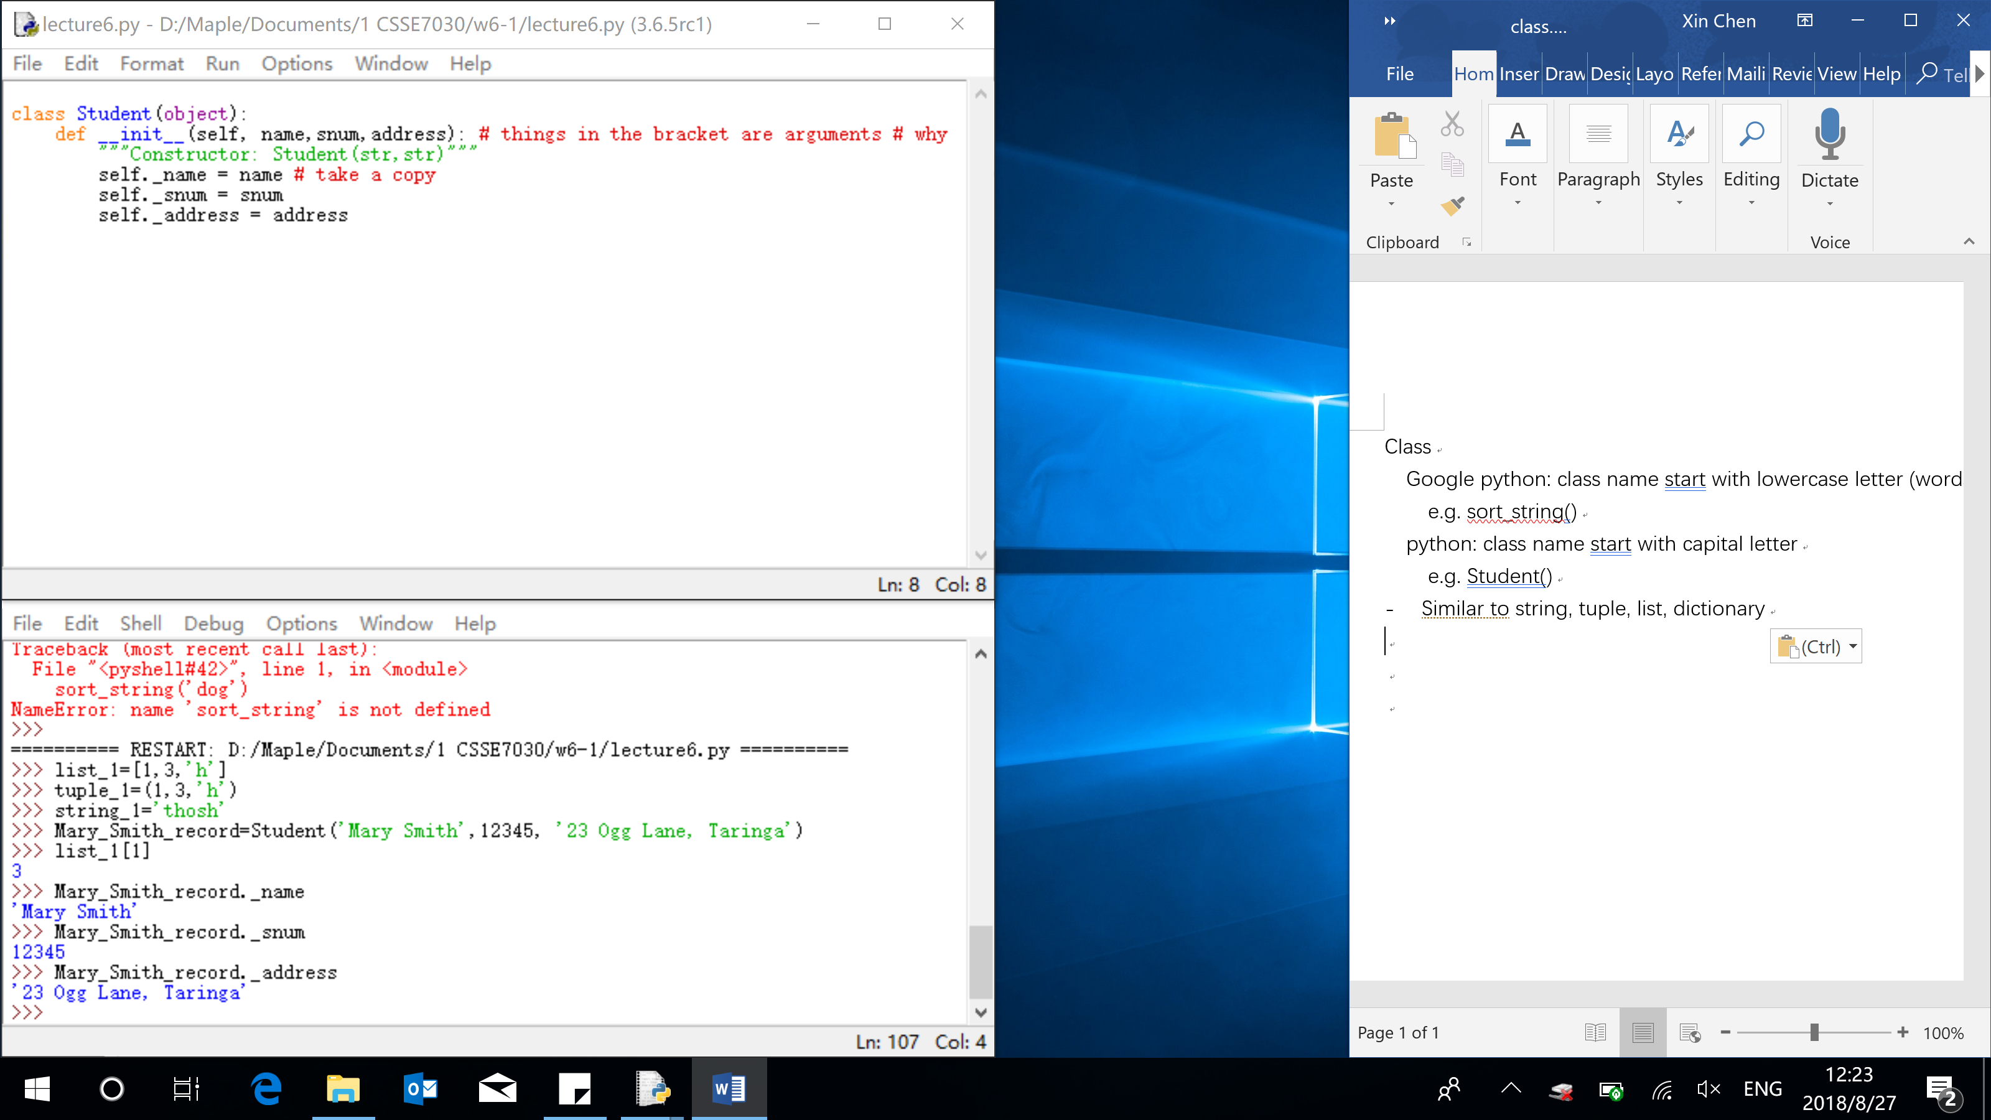



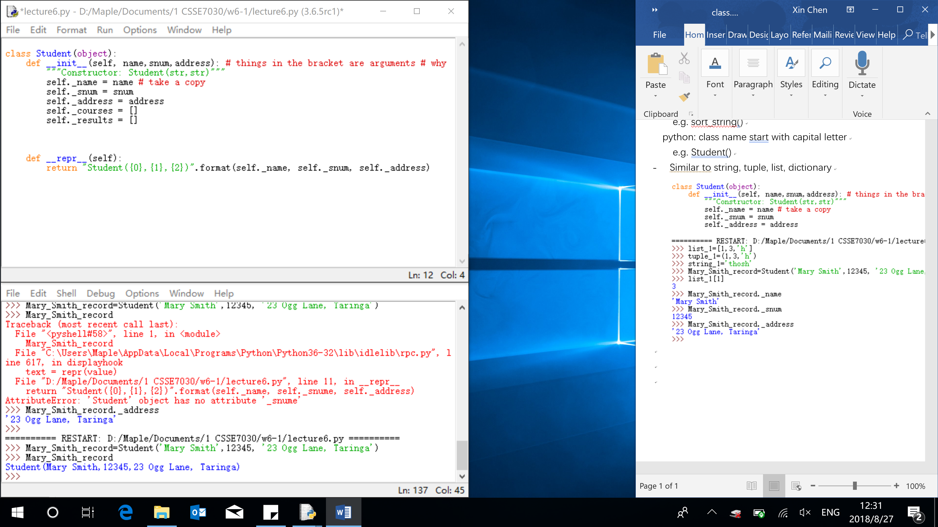



Extend V.S. append V.S. update:

Update – dictionary

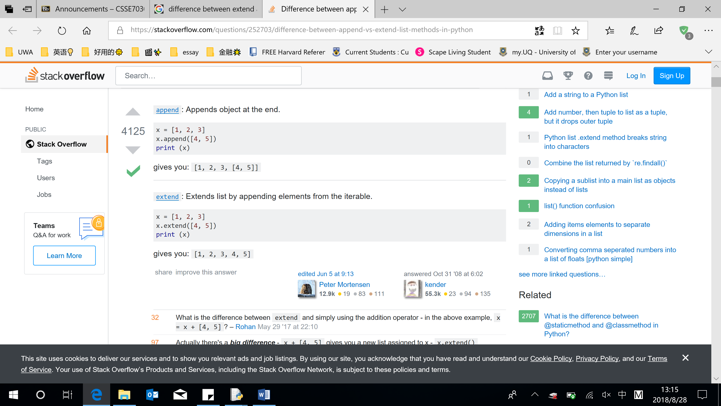

Interaction with 2 objects in the same class

